Fall 2018, CS5551: Advanced Software Engineering Department of Computer Science Electrical Engineering University of Missouri-Kansas City

**Travel Explorer**

Saran Akkiraju

Pallavi Desai

Harish Tata

Mastan Krishna Neeraj Padarthi

App Demo: <https://www.youtube.com/watch?v=p-TR1Kag8rg&feature=youtu.be>

GitHub: <https://github.com/SaranAkkiraju/CS5551_Team8_Project>

ZenHub: <https://github.com/SaranAkkiraju/CS5551_Team8_Project#workspaces/cs5551-team8-project-5b7f444ae7c511269ddc1c12/boards?repos=145917717>

# Acknowledgement Statement:

This work has been completed under the guidance of Dr. Yugi Lee and the TAs (Ruthvic Punyamurtula, Sravanthi Gogadi , Bhargavi Nadendla) in CS5551 Advanced Software Engineering, University of Missouri - Kansas City), Fall 2018.

# Project Deployment

Travel Explorer User Manual

By,

Saran Akkiraju

Pallavi Desai

Harish Tata

Mastan Krishna Neeraj Padarthi

Table of contents:

1. Introduction
2. How to use the system with Screen dumps
   1. Accessing
   2. Web App Usage
      1. Home page
      2. Make your own trip page
      3. Itinerary page
      4. Search History Page
3. Error recognition and handling
4. Bugs and Deficiencies
5. Introduction - Web Application to helps user to plan trip within budget and number of days. This App allows user to do the following:
   1. Login to web app using Facebook or Google or App Credentials.
   2. If user does not have account yet user can register.
   3. Shows user list of places to visit in the city user entered.
   4. Web App will let user make customized plan.
   5. Web App will provide itinerary to user that is within user’s budget and days.
   6. Shows search history of user
   7. Web app will let user contact admin of the page for queries
6. How to use the system with Screen dumps -
   1. Accessing :
      1. Open URL of our page in web browser.
      2. If do not have account yet register to our application.

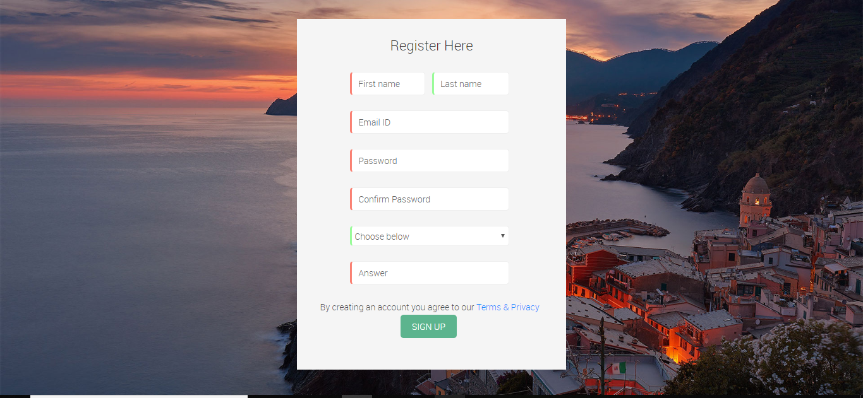

* + 1. Log-in to our application using these credentials or using Facebook or Google Credentials.

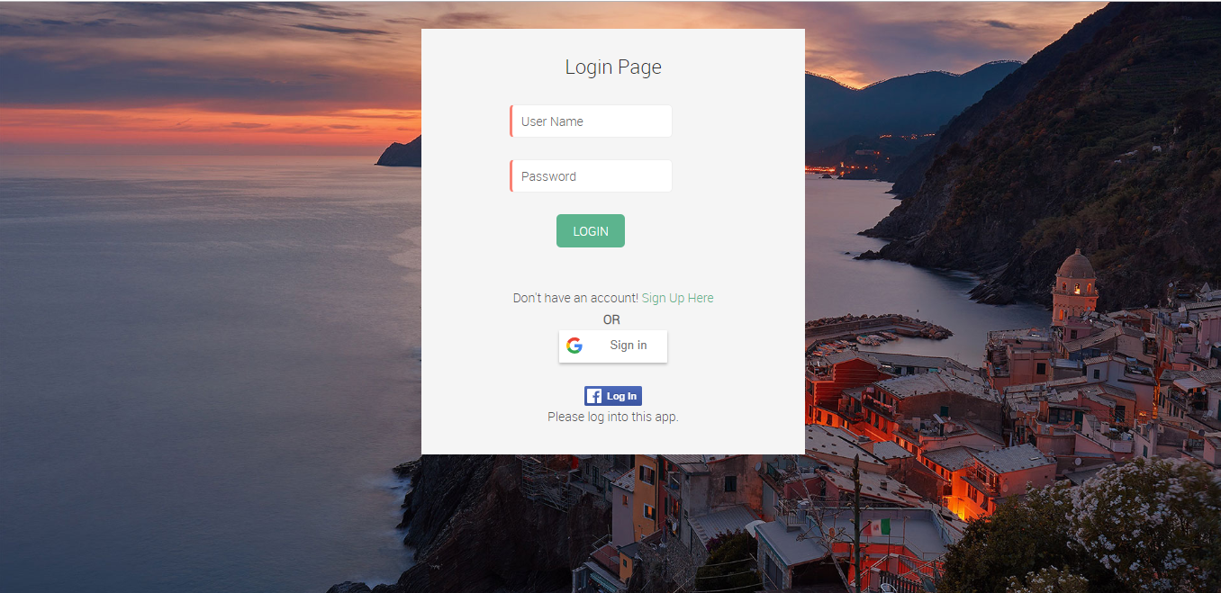

* 1. App Usage :
     1. Home page
        1. Home page of our application will take input from user
        2. If the User enters all the fields and lick Find button , Application will show list of places user can visit in that place.

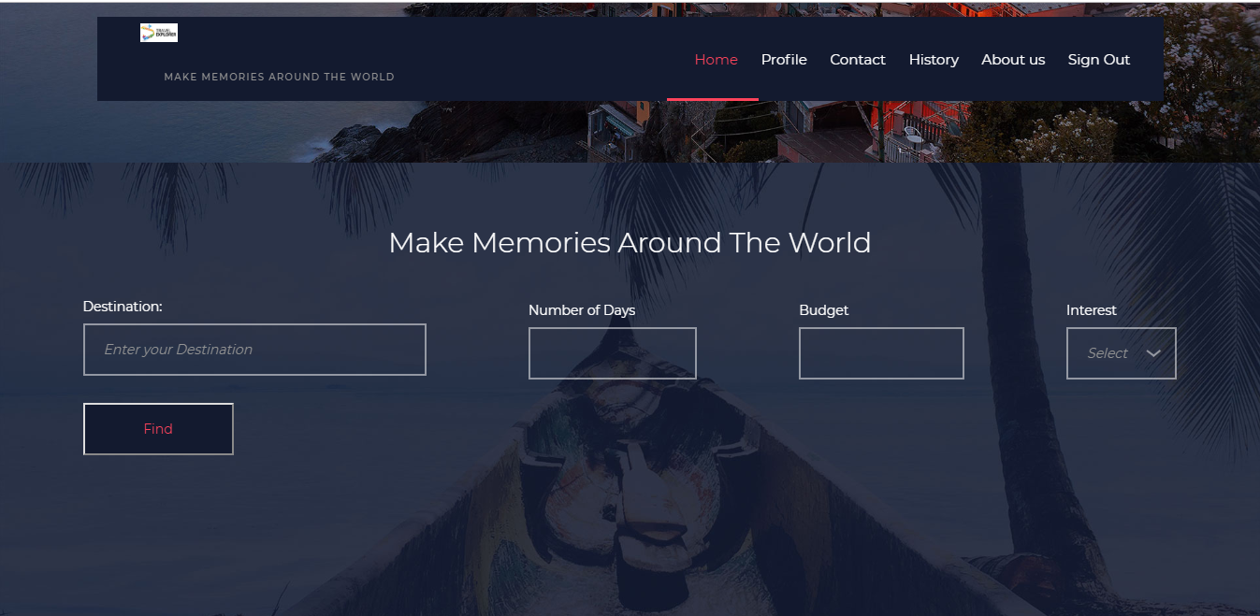

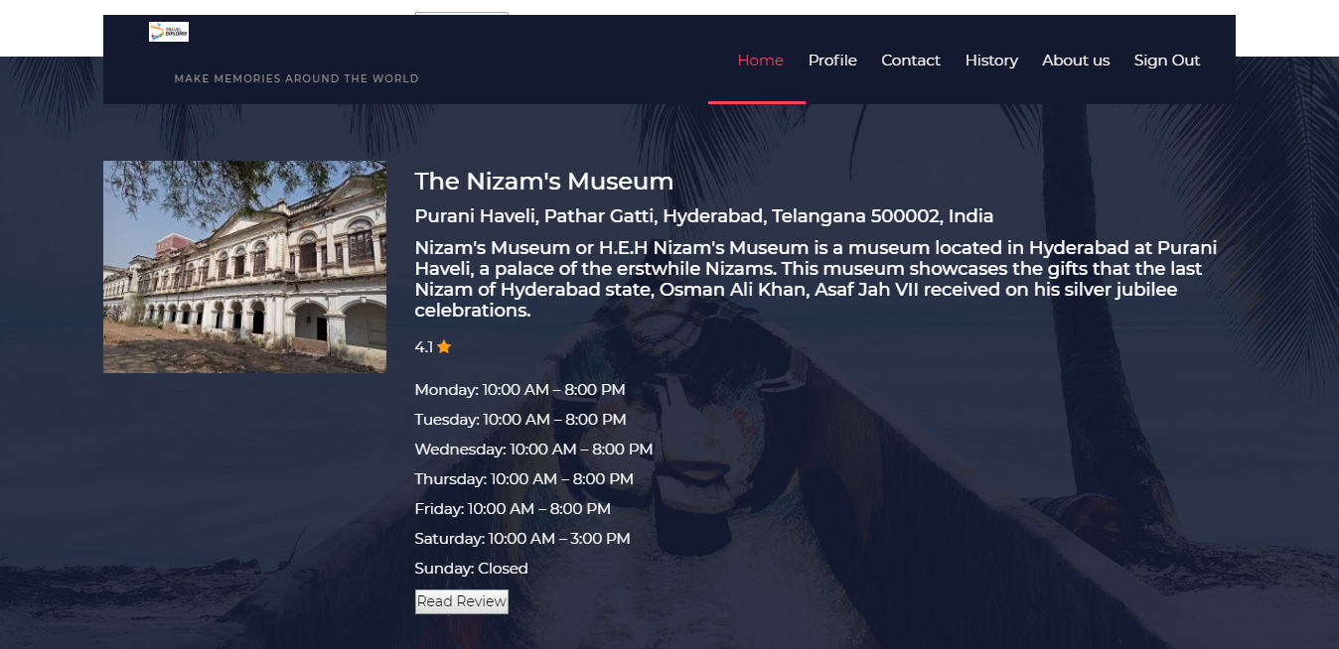

* + 1. Make your own plan page
       1. When user enters fields in home page and clicks make my own trip, user will be redirected to this page
       2. This page will consist of all places user could visit in that area
       3. User will be allowed to select the places user wants to visit
       4. User will be given with the plan , which places to visit in sequence considering shortest distance

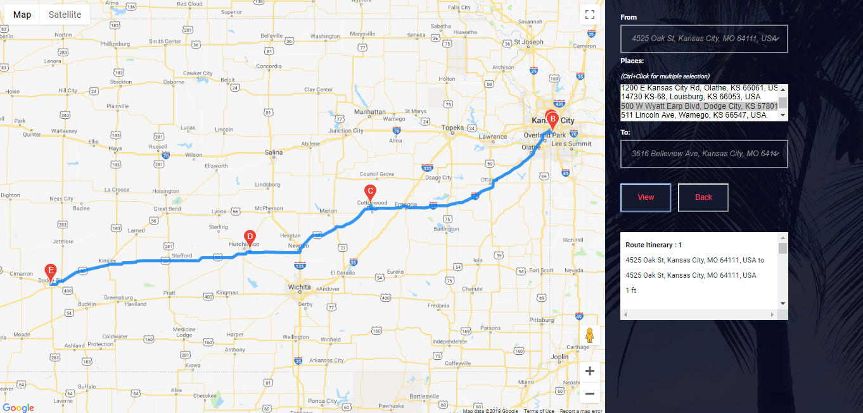

* + 1. Itinerary page
       1. When user enters all the fields in home page and clicks get Itinerary button user will be redirected to this page
       2. Efficient plan will be provided to user based on users budget and number of days entered by the user.

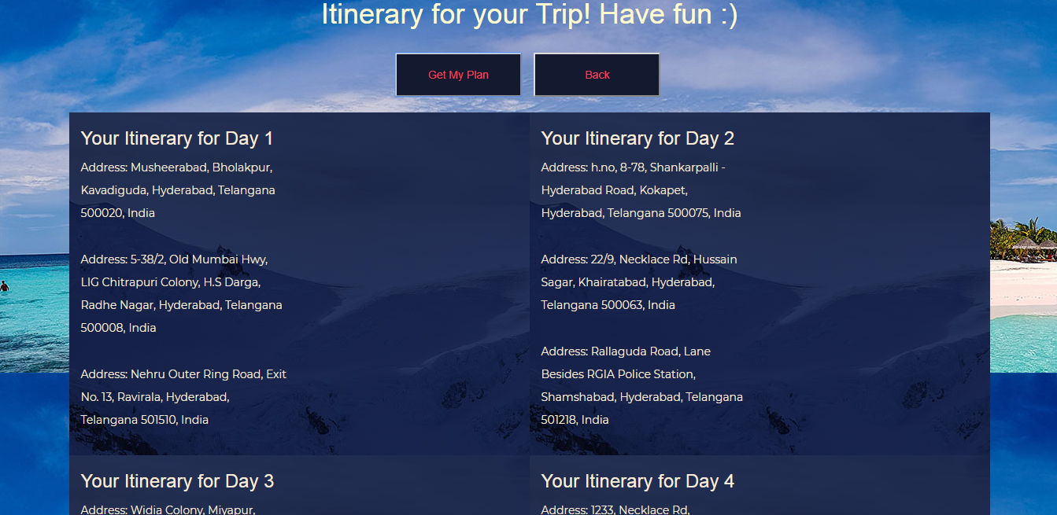

* + 1. Search History
       1. Previous searches user did will be shown in this page. It includes all the option that user selected while performing search.

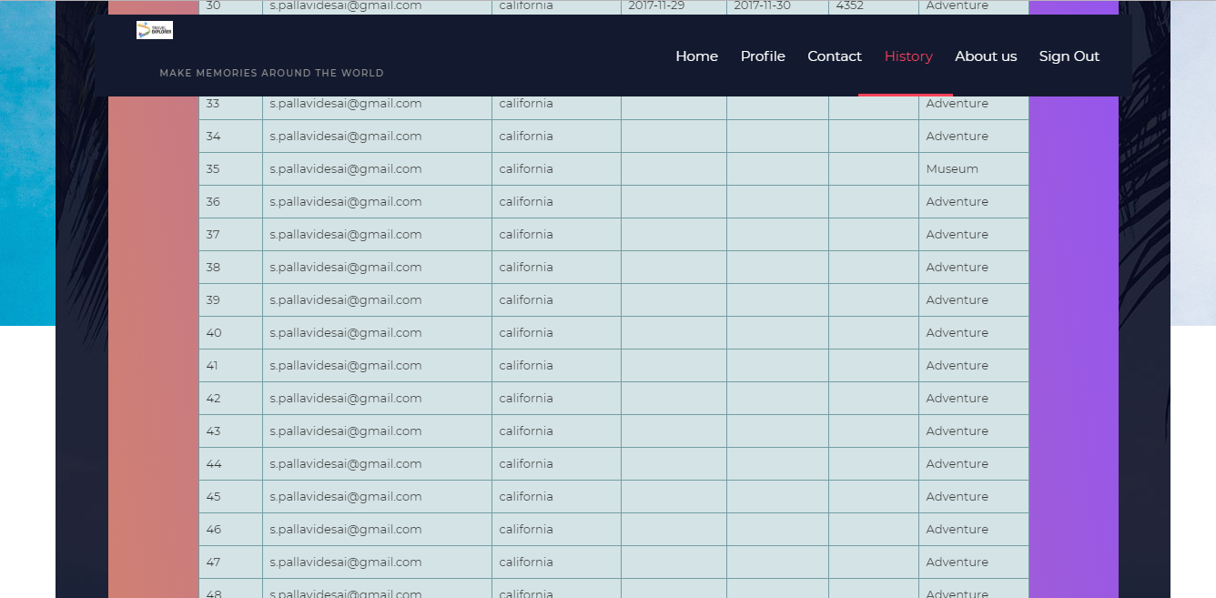

1. Error recognition and handling -
   1. Once the User views the itinerary from the application and clicks on map button to see the map of day, user can’t return to the same itinerary page. User will have to go to home and then click button to return to the itinerary page.
2. Bugs and Deficiencies -
   1. User will not be allowed to select multiple interests in out page
   2. Budget we are considering do not include hotel and travelling charges
   3. Our application will require some seconds to load all the data related to place since we are using multiple APIs.

## Project management report:

**Project Management**

This is the first time that we were doing project with so neatly planned steps. We divided our project so that it will be completed in 3 increments and sticked to it.

Before starting each increment we first planned out what functionalities need to be implemented and made it as user stories. We then divided the user stories among themselves.

It went very smoothly and we all agree that Agile is the best for project development when we are developing a new product. We have used Zenhub to create user stories and manage them. Below I am including burndown chart and user stories of our increment 3 to demonstrate the point.

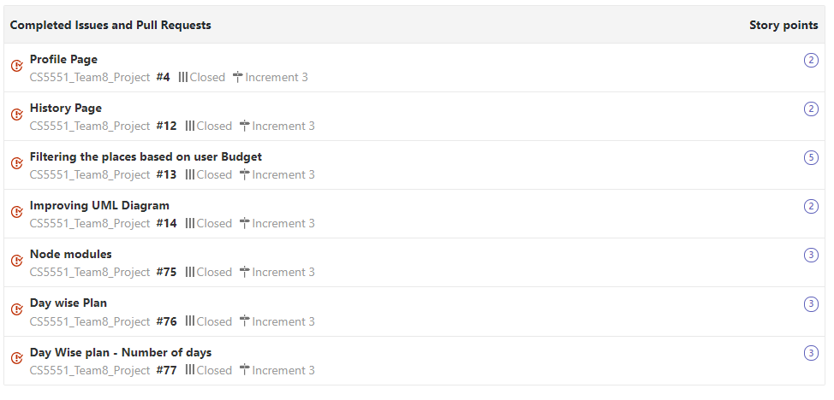

**ZenHub report:**

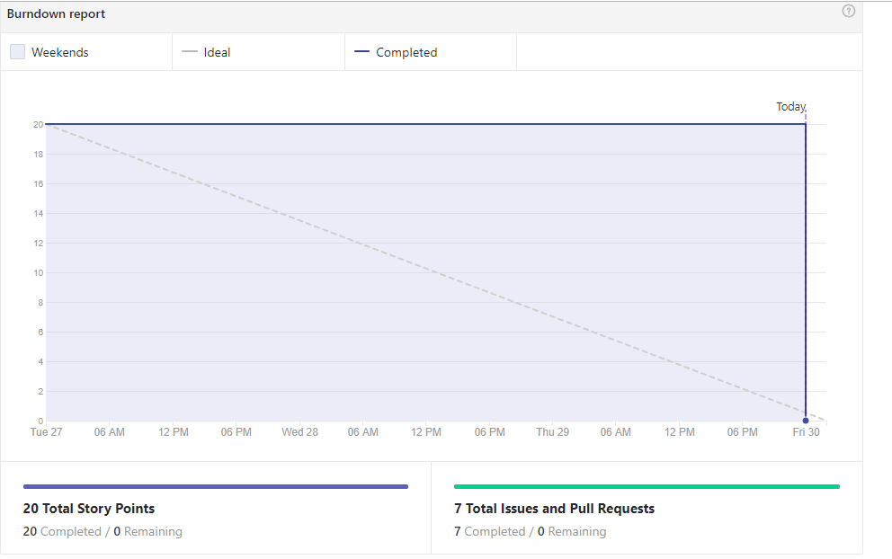

**Team member's contributions:**

Every one of our team got equally involved in the all the phases of our project.

Each one of us were involved in design, coding and testing phases.

* Saran:
  + Saran was equally involved in all the phases of our project
  + Implemented Google Places search API for getting places of a particular city and sorted the places according to rating of the Places.
  + Handled all node mailer modules used in our project.

## Points: 25

* Pallavi:
  + Pallavi was equally involved in all the phases of our project
  + Implemented Google Places Id API for getting the place weekly hour information and user reviews and Knowledge Graph API for getting the description of a particular place.
  + UI of our project was worked on by Pallavi.

## Points: 25

* Harish:
  + Harish was equally involved in all the phases of our project

## Migration from local storage to MongoDB for registering and login purposes, implemented Image API which displays the image by taking the photo reference string from Places Search API.

## Storing user details and all monogo CRUD operation was handled by Harsih

## Points: 20

* Neeraj:

## Neeraj was equally involved in all the phases of our project

## Implemented google maps API including the way points, where the user enters from, to and can add waypoints in between. The result would display the itinerary from one location to another location based on their distances.

## Neeraj took care of all maps and its implementation of maps in our project

## Points: 20

**Final project evaluation**:

* *How well your project satisfies your original requirement specifications?*
  + We have implemented almost 90% of our requirements we had set .
  + We need to focus more on nonfunctional requirements of our project
* *Were you satisfied with your design process?*
  + The design process of our project went good. But later in development phase we had to change some design ideas. But basic idea was kept intact and yes we are satisfied.
* *How helpful was the agile process? How would you do the agile process next time?*
  + It was very helpful to plan our tasks accordingly and I strongly refer this for projects with team.
* *Did you stick to your project plan schedule?*
  + I would say big yes to this question
  + We started doing things very early to stick to our plan
* *What was the real management structure within your group?*
  + Saran acted as scrum master for us and all team members were actively involved in design and we loved our team work.
* *Does it bear any resemblance to structure that you had planned?*
  + Looks similar in big picture but small details are modified.
* *Did you have any problems getting each member to do his/her share of the work?*
  + Zenhub did the job for us and no did not have any problem.
* *Do you have any suggestion on how this could have been handled better?*
  + We liked the way it is done.
* *Discuss what you might have done differently if this were a real world project?*
  + We did not think of scalability as issue now but we know its going to be big issue in real world application. May be we might have focused on it more.
* *Any recommendations for next year?*
  + Check demo of projects thoroughly

# Presentation Slides

Slide1:

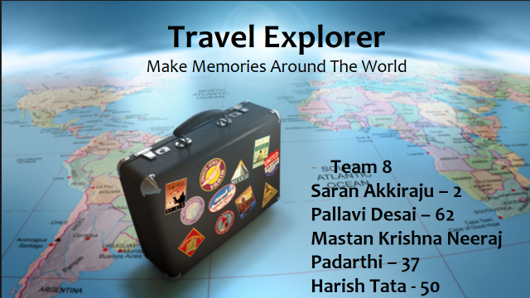

Slide2:

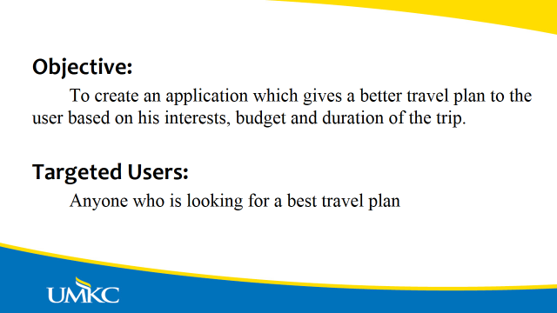

Slide 3:

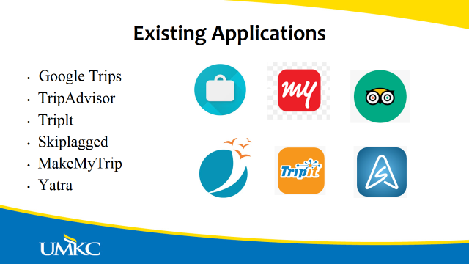

Slide 4:



Slide 5:

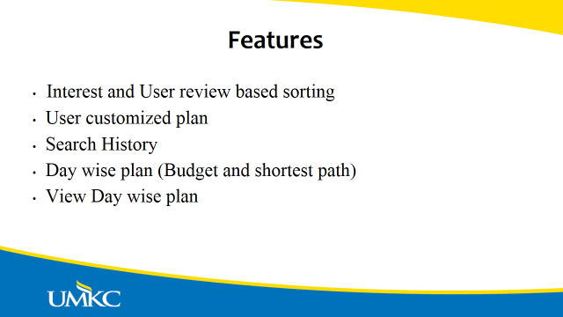

Slide 6:

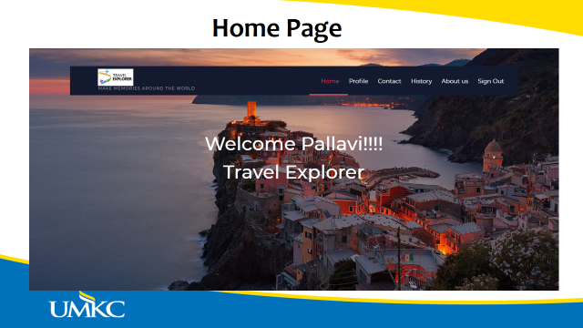

Slide 7:

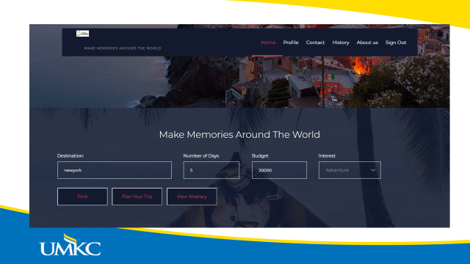

Slide 8:

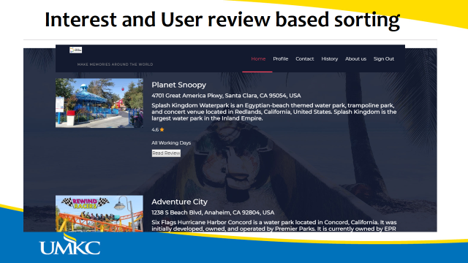

Slide 9:

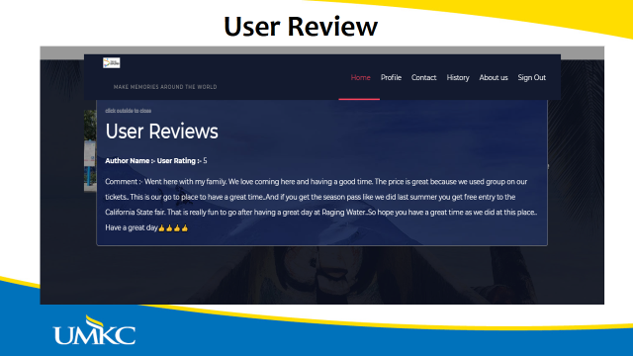

Slide 10:

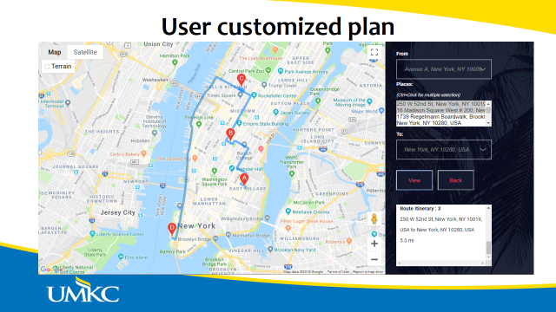

Slide 11:

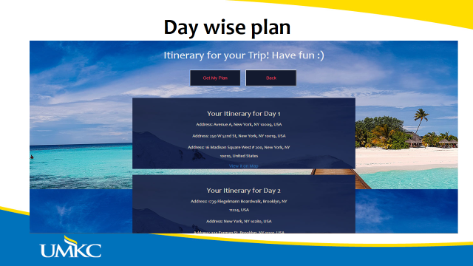

Slide 12:

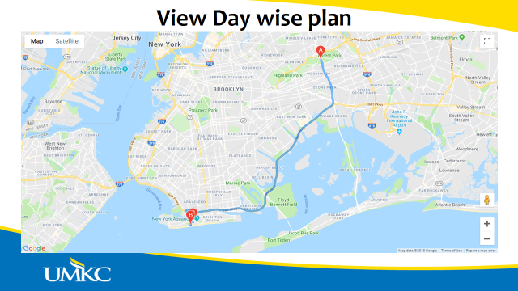

Slide 13:

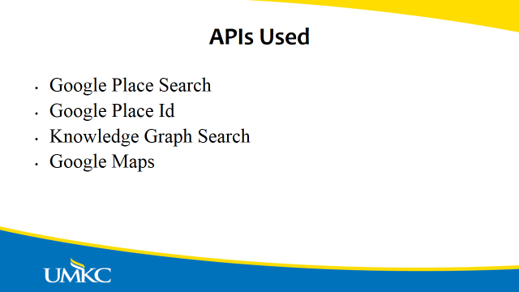

Slide 14:

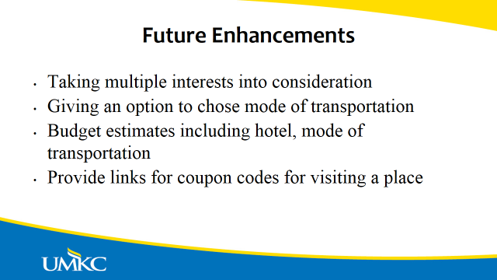

## Project Proposal and Plan

## Project Team

## Saran Akkiarju - 2

## Pallavi Desai – 62

## Harish Tata – 50

## Mastan Krishna Neeraj Padarthi - 37

## Project Goal:

**Motivation**:

Planning a vacation within budget takes serious brainstorming, specially if someone is new to that area. May be vague plan we do cost lot of money than it would cost with a proper plan. Or if we just stick to budget we may miss out places worth visiting in that area. So it would be very convenient if there is a system that takes all our interests and duration and give us appropriate plan taking into consideration of our time, money and interest constraints.

## Significance:

## There are many existing websites which gives us travel guidance. These websites are well established and are friendly to use, for example take google travel or make my trip etc. But what they do lack is they do not take users concerns like what user likes to visit or is it within budget of user or duration all together. Usually the important concern will be budget which no other existing website will cover.

## Objectives:

## Primary objective of this project is to provide user with a felicitous plan by taking user's input like budget, duration and interests. User will have to select interests like adventurous, pilgrimages, scenic, cultural. User will be getting plan that is within budget of user and covers user’s interests and fits within duration.

## System Features:

I. User shall be able to login to system using username and password.

II. User shall be able to register if he/she do not have account yet.

III. User shall be able to login using Google and Facebook.

IV. User shall use the system with good and interactive GUI.

V. User shall able to input interests, duration and Budget.

VI. System shall have germane algorithm which will come up with a proper plan that is within budget and duration mentioned and includes user's interest.

VII. User shall able to view plan with understandable layout.

## Related Work:

There is existing application "Google trips" which gives appropriate plans based on user interest.

**Project First Increment Report**

**Features developed for Increment1:**

1. Homepage
2. Login/Logout feature
3. Registration page
4. Contact Us page
5. About Us page

**Existing Services/REST API:**

<https://developers.google.com/knowledge-graph/>

<https://console.developers.google.com/google/maps-apis/>

**Detail Design of Features:**

**1. Wireframes& mockup:**

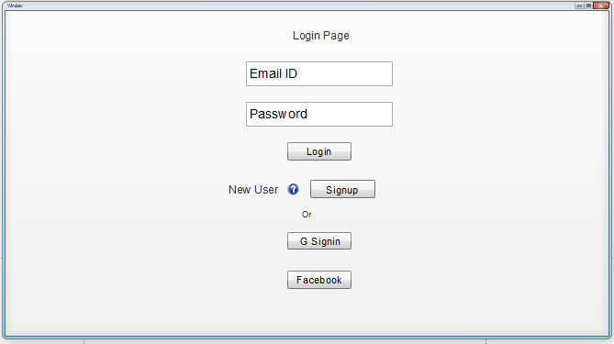

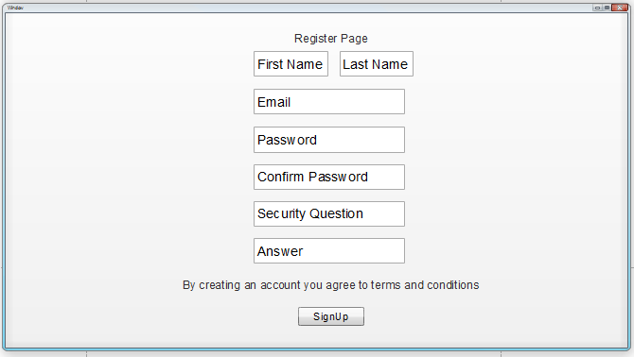

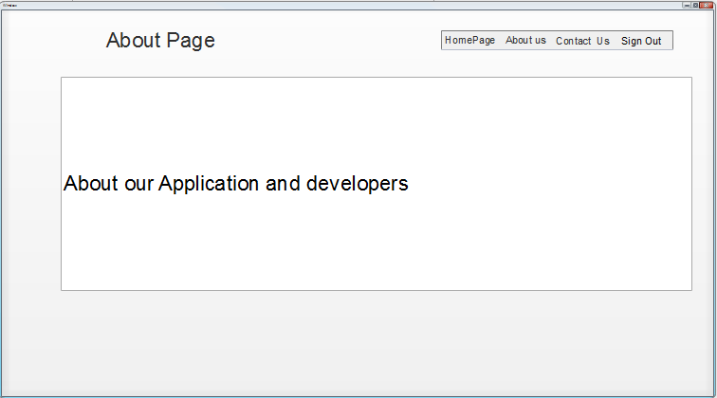

**Basic Functionality:**

First thing that a user should be seeing is a Login page, which has a username and password fields. Once the user provides his/her username and password he/she will be prompted to home page. Login can also be done using Google and Facebook.

User registration is required before logging into the application, on clicking Sign up here link in the login page, user will be prompted to Registration page, where user has to enter details like First name, Last name, Email id, Password, Conform Password, Security question and its Answer, a link to comply with Terms and conditions and then press Signup button.

After successful registration user will be asked to login to the application, after logging in user will be prompted to Home page. Home page consists of tabs to Contact Us, About Us pages where user can see the details of Admin and about the application details.

In Home Page we have 5 fields Destination(Place field), Date (from and to), Budget and Interest. User have to give the destination (place field) and interest. The places list with fields like Name, Address, Rating, Weekday hours and user reviews are shown of that place based on the Destination and Interest given by the user.

Any point of time user can logout from the system upon pressing Logout button.

**2. 1 Architecture diagram:**

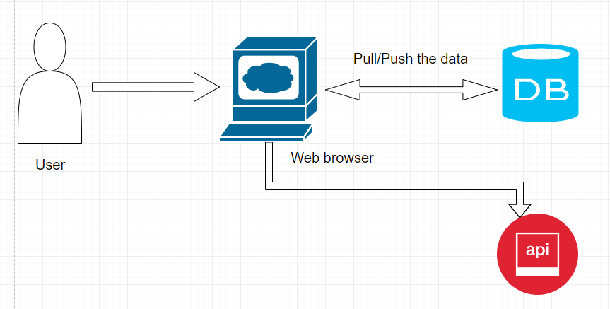

**2.2 Sequence Diagram:**

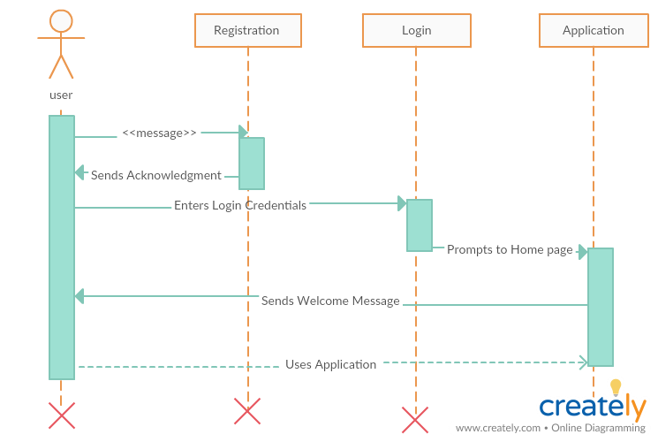

**2.3 Class Diagram:**

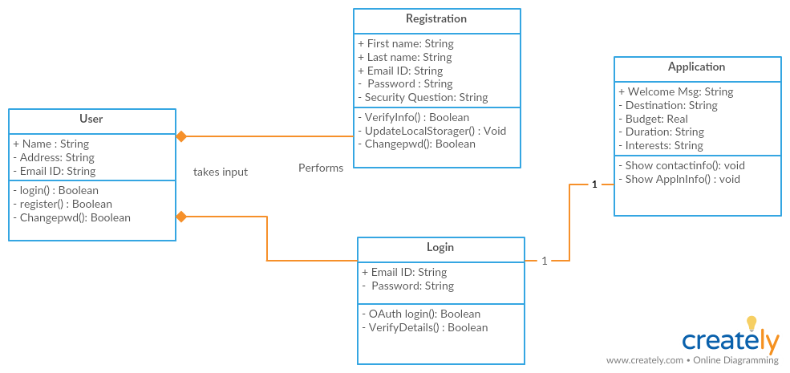

**3. User Stories**

|  |  |  |
| --- | --- | --- |
| **As a** | **I want to** | **So that** |
| User | Login using user name and password. | I can use website. |
|  |  |  |
| User | Register, if I do not have account. | I can login and use website. |
|  |  |  |
| User | Login Using Google and Facebook. | I don’t have to register and directly can use system. |
|  |  |  |
| User | Contact developers and  Know about website | I can ask for assistance if I have any queries and I can understand how to use website. |
|  |  |  |
| User | .Create UML Diagrams | Structure and flow of code will be understood |
|  |  |  |

## 4. Testing

|  |  |  |  |  |  |
| --- | --- | --- | --- | --- | --- |
| **ID** | **Test Case** | **Test Case Description** | **Input** | **Expected** | **Result** |
| 1.1 | Register | Open Web application and select new user and signup option. | User clicks on signup button. | Register page opens up. | Pass |
| 1.2 | Register | User enters first name with only alphabets. | User fills out first name field. | Application should accept it | Pass |
| 1.3 | Register | User fills out first name fields with numbers or Special characters. | User fills out first name field. | Application should show error message. | Pass |
| 1.4 | Register | User enters last name with only alphabets. | User fills out last name field. | Application should accept it | Pass |
| 1.5 | Register | User fills out last name fields with numbers or Special characters. | User fills out last name field. | Application should show error message. | Pass |
| 1.6 | Register | User fills out email which is preceded with @ and .com | User fills out email fields. | Application should accept it | Pass |
| 1.7 | Register | User fills out email which is not preceded with @ and .com | User fills out email fields. | Application should show error message. | Pass |
| 1.8 | Register | Password and confirm password matches. | User fills out password and confirm password field. | Application should accept it | Pass |
| 1.9 | Register | Password and confirm password doesn’t match. | User fills out password and confirm password field. | Application should show error message. | Pass |
| 1.10 | Register | User leaves Mandatory field empty. | User fills out input fields. | Application should show error message | Pass |
| 1.11 | Register | User fills out all Mandatory fields. | User fills out input fields. | Application should accept it | Pass |
| 1.12 | Register | After entering input fields User clicks Register button. | User click Register button. | All input entered by user should be taken and stored and is redirected to login page. | Pass |
| 2.1 | Login | With Valid Username and Password. | User enters Valid Username and Password. And press login button | Should redirect Home page | Pass |
| 2.2 | Login | With Invalid Username and valid Password. | User enters invalid Username and valid Password and press login button | Should Show incorrect Username error message | Pass |
| 2.3 | Login | With Valid Username and invalid Password. | User enters Valid Username and invalid Password and press login button | Should Show incorrect password error message | Pass |
| 2.4 | Login | With invalid Username and invalid Password. | User enters invalid Username and invalid Password and press login button | Show incorrect credentials error message | Pass |
| 2.5 | Login | User without registration can also login using Google. | User enters correct Google credentials. | Redirects to homepage. | Pass |
| 2.6 | Login | User without registration can also login using Google. | User enters incorrect Google credentials. | Google shows error message. | Pass |
| 2.7 | Login | User without registration can also login using Facebook. | User enters correct Facebook credentials. | Redirects to homepage. | Pass |
| 2.8 | Login | User without registration can also login using Facebook. | User enters incorrect Facebook credentials. | Facebook shows error message. | Pass |
| 3.1 | About | User Successfully logins and press About tab. | User press About button. | About Page should open that contains website details. | Pass |
| 4.1 | Contact | User Successfully logins and press Contact tab. | User press Contact button. | About Page should open that contains contact details. | Pass |
| 5.1 | Logout | User will be logged out from website. | User clicks logout button. | Should be logged out of application and redirected to login page. | Pass |

**Travel Explorer – Web Application:**

**Login Page**

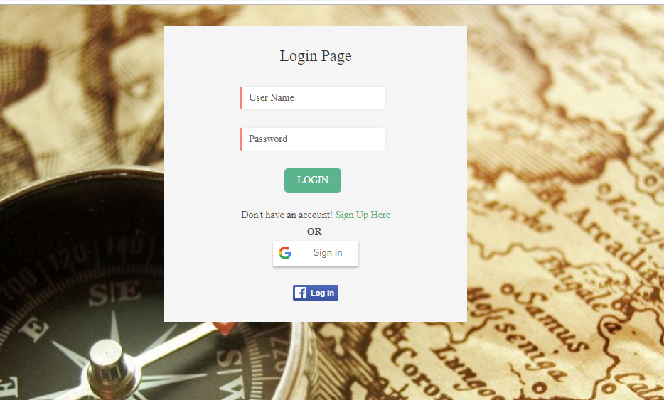

This is the first page that a user will be seeing upon reaching to website. Registration of a user is must before logging into the system. User can login with his credentials entered during Registration or can login using Google or Facebook authentication.

User will be successfully logged into the system if Credentials are right, if Username and Password does not match, user will be prompted that the credentials are wrong.

**Registration Page**

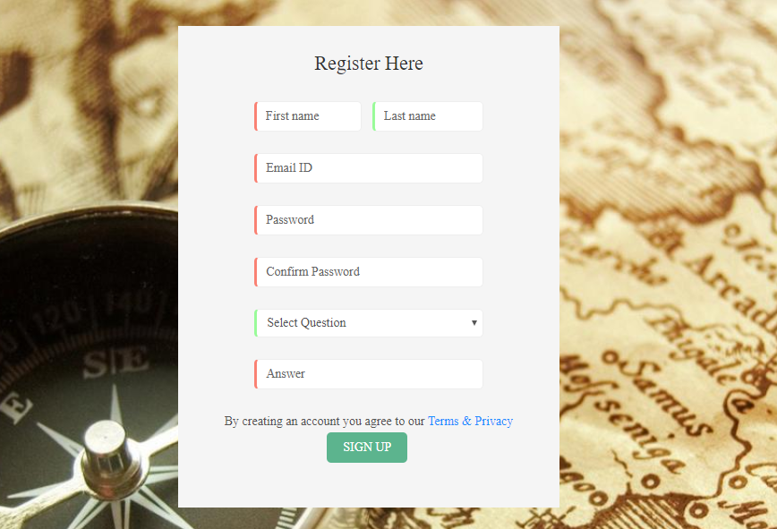

Upon clicking Sign Up Here link in the Login Page user will be prompted to Registration page,

here user should enter the details like First Name, Last Name, Password, Confirm Password,

Choose a Security Question, Answer for it and has to agree to Terms and conditions. Upon pressing Signup button user will be successfully registered.

User will now be prompted to Login Page, Some fields in the Registration Page are mandatory.

**Home Page**

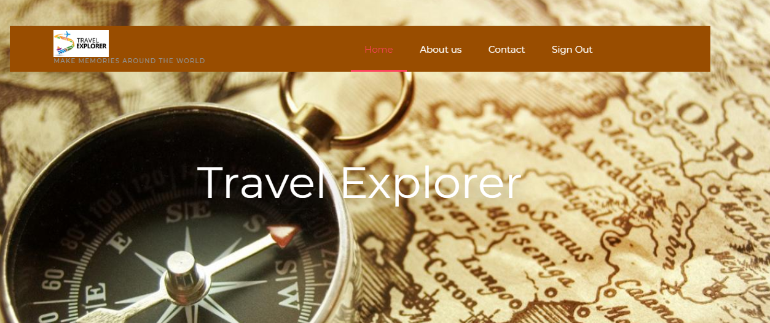

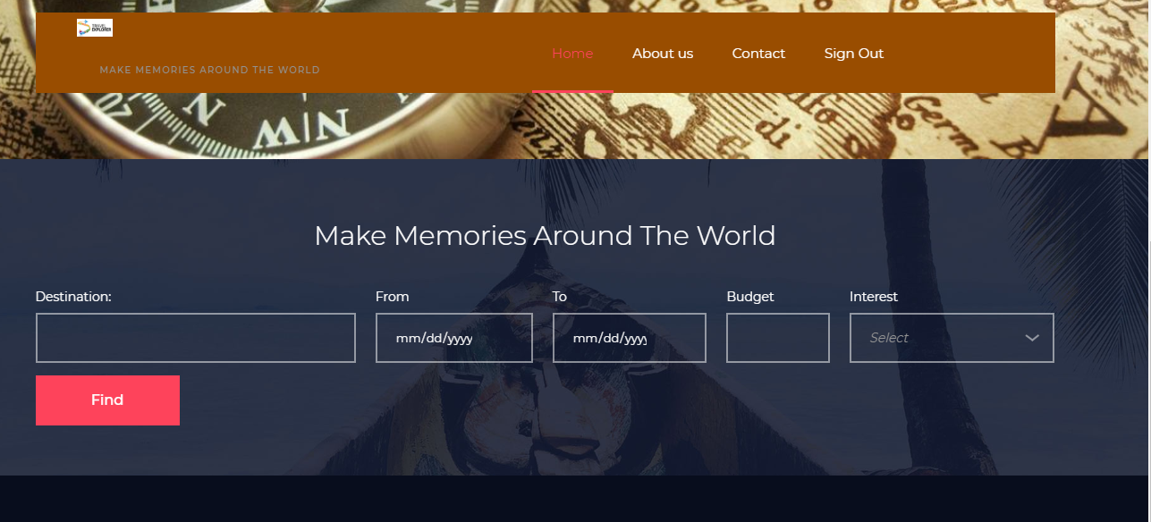

Home page consists of a Tab which links to Contact, About Us pages and to Logout from the System. It takes the User Input of Destination, from and to dates of the trip, Budget of the User and Interests.

**About Us**

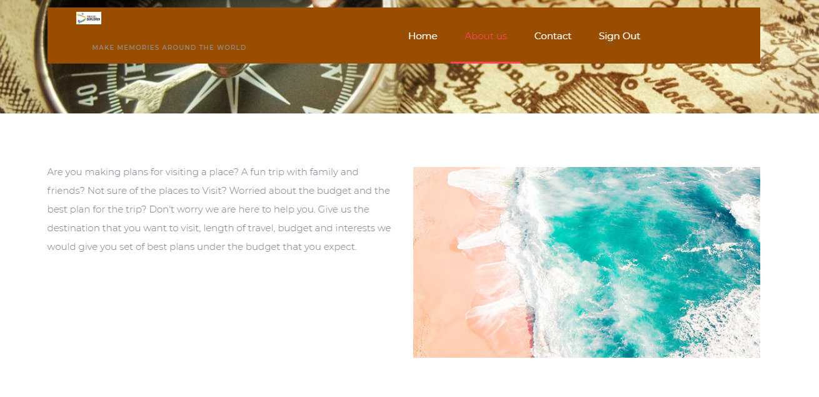

This page tells about why a user should be using our website.

**Contact Page**

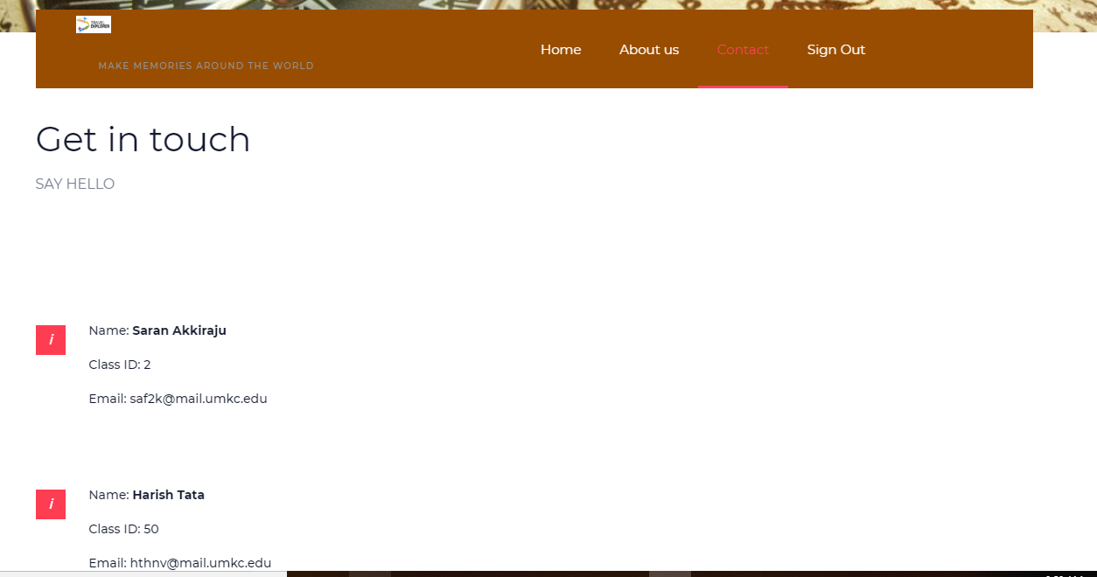

**Please find Github Wiki below:**

https://github.com/shannu1221/CS5551_Team8_Project/wiki/Project-Increment-1

**Project Management**

**Board Issues:**

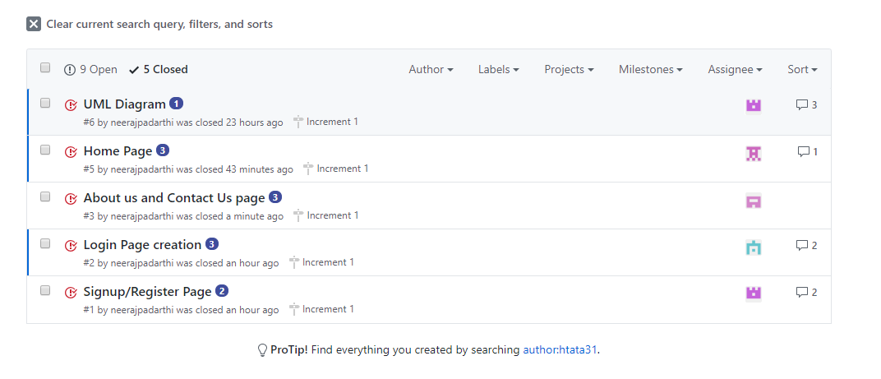

**ZenHub report:**

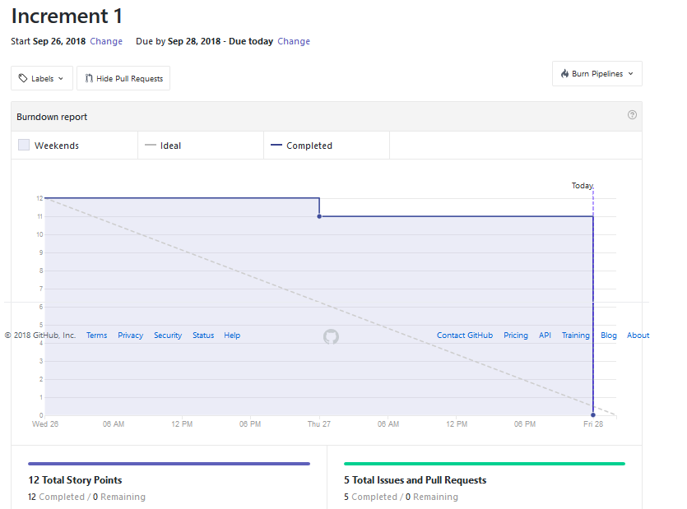

**Contribution chart:**

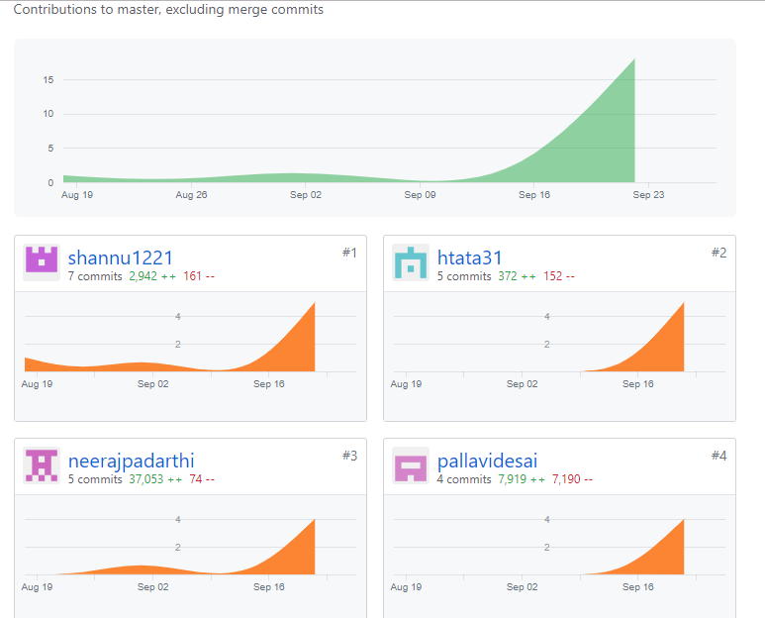

**Project Second Increment Report**

**Features developed for Increment2:**

1. Displaying places of a city, given destination from the user
2. Displaying places of Interest, given destination and Interest from the user
3. Displaying User reviews of a given place
4. Migrating from Local Storage to Mango DB

**Existing Services/REST API:**

<https://console.developers.google.com/google/maps-apis/>

<https://developers.google.com/places/web-service/search>

<https://developers.google.com/places/web-service/details>

<https://developers.google.com/places/web-service/photos>

**Detail Design of Features:**

1. **Wireframes& mockup:**
2. **Login Page**



1. **Register Page**

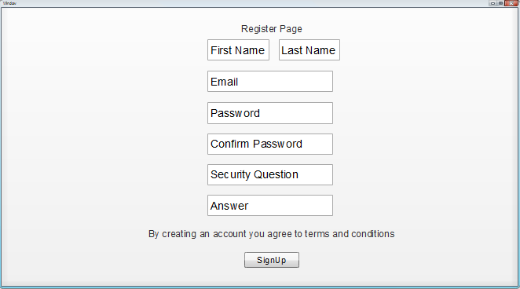

1. **About Page**



1. **Contact Page**

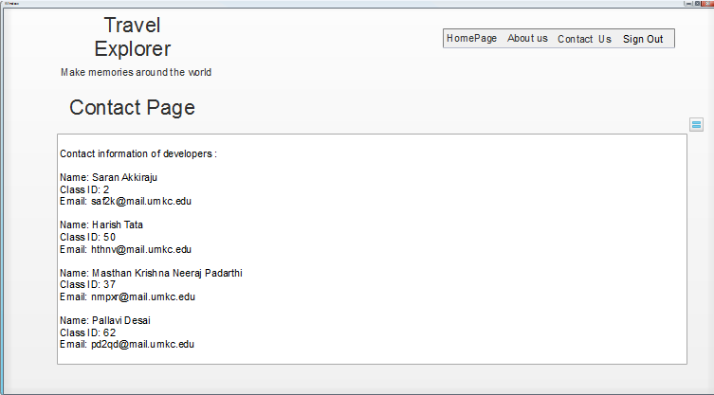

1. **Home Page**

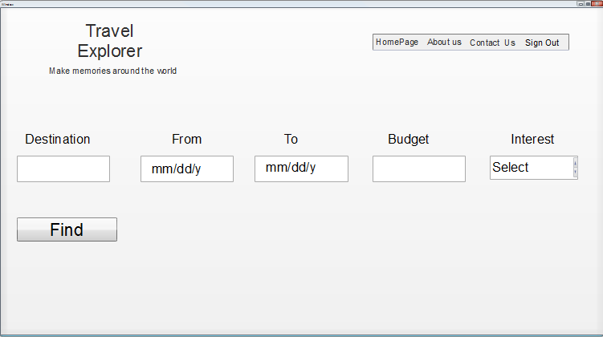

1. **Displaying search results in Home Page**

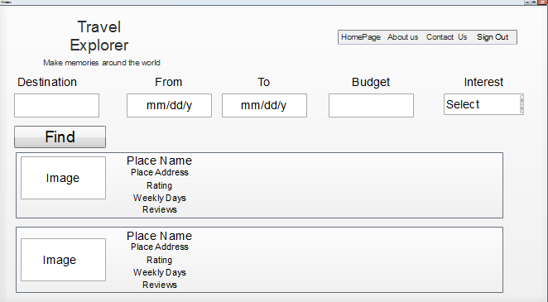

**Basic Functionality:**

First thing that a user should be seeing is a Login page, which has a username and password fields. Once the user provides his/her username and password he/she will be prompted to home page. Login can also be done using Google and Facebook.

User registration is required before logging into the application, on clicking Sign up here link in the login page, user will be prompted to Registration page, where user has to enter details like First name, Last name, Email id, Password, Conform Password, Security question and its Answer, a link to comply with Terms and conditions and then press Signup button.

After successful registration user will be asked to login to the application, after logging in user will be prompted to Home page. Home page consists of tabs to Contact Us, About Us pages where user can see the details of Admin and about the application details.

In Home Page we have 5 fields Destination(Place field), Date (from and to), Budget and Interest. User have to give the destination (place field) and interest. The places list with fields like Name, Address, Rating, Weekday hours and user reviews are shown of that place based on the Destination and Interest given by the user.

Any point of time user can logout from the system upon pressing Logout button.

**2. 1 Architecture diagram:**



**2.2 Sequence Diagram:**

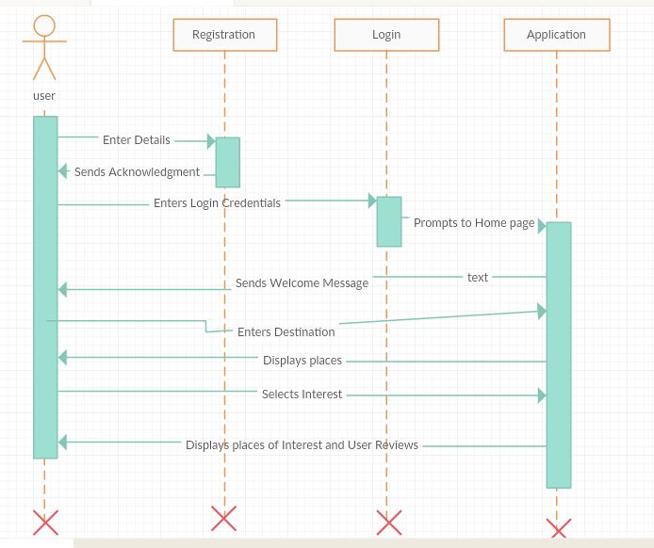

**2.3 Class Diagram:**

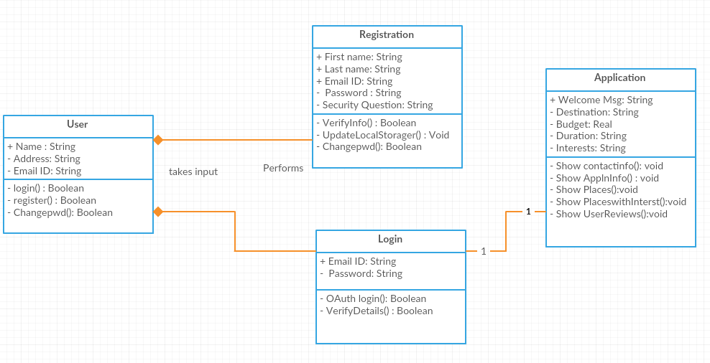

**3. User Stories**

|  |  |  |
| --- | --- | --- |
| **As a** | **I want to** | **So that** |
| User | See list of places of a given destination | I can select from the places available |
|  |  |  |
| User | Filter the places based on my interest | I can select my places of interest |
|  |  |  |
| User | See the Ratings and User Reviews of the given place | I can make the best choice |
|  |  |  |
| Developer | Migrate the local storage to MongoDB | I can access my data from cloud |
|  |  |  |
| User | Create UML Diagrams | Structure and flow of code will be understood |
|  |  |  |

**4. Testing**

|  |  |  |  |  |  |
| --- | --- | --- | --- | --- | --- |
| **ID** | **Test Case** | **Test Case Description** | **Input** | **Expected** | **Result** |
| 1.1 | Register | Open Web application and select new user and signup option. | User clicks on signup button. | Register page opens up. | Pass |
| 1.2 | Register | User enters first name with only alphabets. | User fills out first name field. | Application should accept it | Pass |
| 1.3 | Register | User fills out first name fields with numbers or Special characters. | User fills out first name field. | Application should show error message. | Pass |
| 1.4 | Register | User enters last name with only alphabets. | User fills out last name field. | Application should accept it | Pass |
| 1.5 | Register | User fills out last name fields with numbers or Special characters. | User fills out last name field. | Application should show error message. | Pass |
| 1.6 | Register | User fills out email which is preceded with @ and .com | User fills out email fields. | Application should accept it | Pass |
| 1.7 | Register | User fills out email which is not preceded with @ and .com | User fills out email fields. | Application should show error message. | Pass |
| 1.8 | Register | User entering same email ID again | User Name Already Available | User Name Already Available | Pass |
| 1.9 | Register | Password and confirm password matches. | User fills out password and confirm password field. | Application should accept it | Pass |
| 1.10 | Register | Password and confirm password don’t match. | User fills out password and confirm password field. | Application should show error message. | Pass |
| 1.11 | Register | User leaves Mandatory field empty. | User fills out input fields. | Application should show error message | Pass |
| 1.12 | Register | User fills out all Mandatory fields. | User fills out input fields. | Application should accept it | Pass |
| 1.13 | Register | After entering input fields User clicks Register button. | User click Register button. | All input entered by user should be taken and stored and is redirected to login page. | Pass |
| 2.1 | Login | With Valid Username and Password. | User enters Valid Username and Password. And press login button | Should redirect Home page | Pass |
| 2.2 | Login | With Invalid Username and valid Password. | User enters invalid Username and valid Password and press login button | Should Show incorrect Username error message | Pass |
| 2.3 | Login | With Valid Username and invalid Password. | User enters Valid Username and invalid Password and press login button | Should Show incorrect password error message | Pass |
| 2.4 | Login | With invalid Username and invalid Password. | User enters invalid Username and invalid Password and press login button | Show incorrect credentials error message | Pass |
| 2.5 | Login | User without registration can also login using Google. | User enters correct Google credentials. | Redirects to homepage. | Pass |
| 2.6 | Login | User without registration can also login using Google. | User enters incorrect Google credentials. | Google shows error message. | Pass |
| 2.7 | Login | User without registration can also login using Facebook. | User enters correct Facebook credentials. | Redirects to homepage. | Pass |
| 2.8 | Login | User without registration can also login using Facebook. | User enters incorrect Facebook credentials. | Facebook shows error message. | Pass |
| 3.1 | Home | Values in the destination field is character | User enters character | No error | Pass |
| 3.2 | Home | Values in the destination field is number | User enters number | Numbers are not allowed in the destination | pass |
| 3.3 | Home | Destination is entered and interest is not selected | Destination: Kansas  Interest: Select | All the places for that destination are displayed | pass |
| 3.4 | Home | Destination is entered and interest is Museum | Destination: Kansas  Interest: Museum | All the Museums for that destination are displayed | pass |
| 3.5 | Home | Destination is entered and interest is Adventure | Destination: Kansas  Interest: Adventure | All the Adventure places for that destination are displayed | pass |
| 3.6 | Home | Destination is entered and interest is Devotional | Destination: Kansas  Interest: Devotional | All the Devotional places for that destination are displayed | pass |
| 3.7 | Home | Destination is entered and interest is Scenic | Destination: Kansas  Interest: Scenic | All the Scenic places for that destination are displayed | pass |
| 3.8 | Home | Destination is entered and interest is Party | Destination: Kansas  Interest: Party | All the Party places for that destination are displayed | pass |
| 4.1 | About | User Successfully logins and press About tab. | User press About button. | About Page should open that contains website details. | Pass |
| 5.1 | Contact | User Successfully logins and press Contact tab. | User press Contact button. | About Page should open that contains contact details. | Pass |
| 6.1 | Logout | User will be logged out from website. | User clicks logout button. | Should be logged out of application and redirected to login page. | Pass |

**Travel Explorer – Web Application:**

**Login Page**



This is the first page that a user will be seeing upon reaching to website. Registration of a user is must before logging into the system. User can login with his credentials entered during Registration or can login using Google or Facebook authentication.

User will be successfully logged into the system if Credentials are right, if Username and Password does not match, user will be prompted that the credentials are wrong.

**Registration Page**



Upon clicking Sign Up Here link in the Login Page user will be prompted to Registration page,

here user should enter the details like First Name, Last Name, Password, Confirm Password,

Choose a Security Question, Answer for it and has to agree to Terms and conditions. Upon pressing Signup button user will be successfully registered.

User will now be prompted to Login Page, Some fields in the Registration Page are mandatory.

**Home Page**



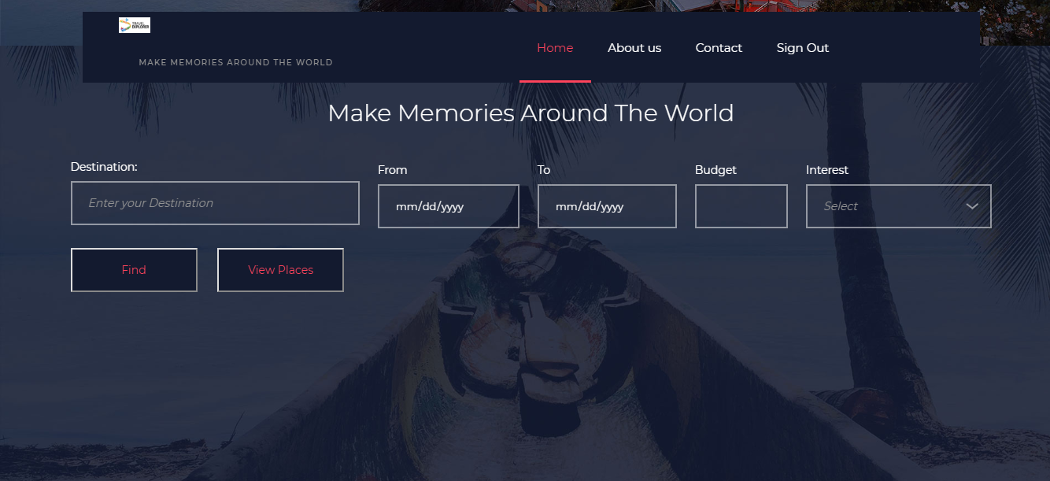

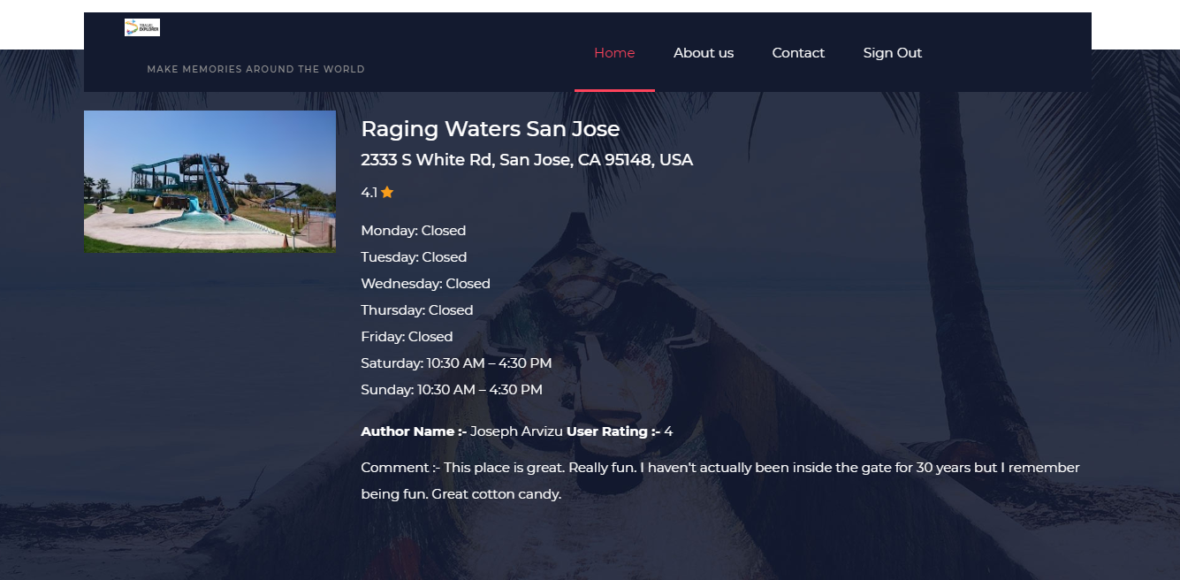

Home page consists of a Tab which links to Contact, About Us pages and to Logout from the System. It takes the User Input of Destination, from and to dates of the trip, Budget of the User and Interests.

**Directions Page**

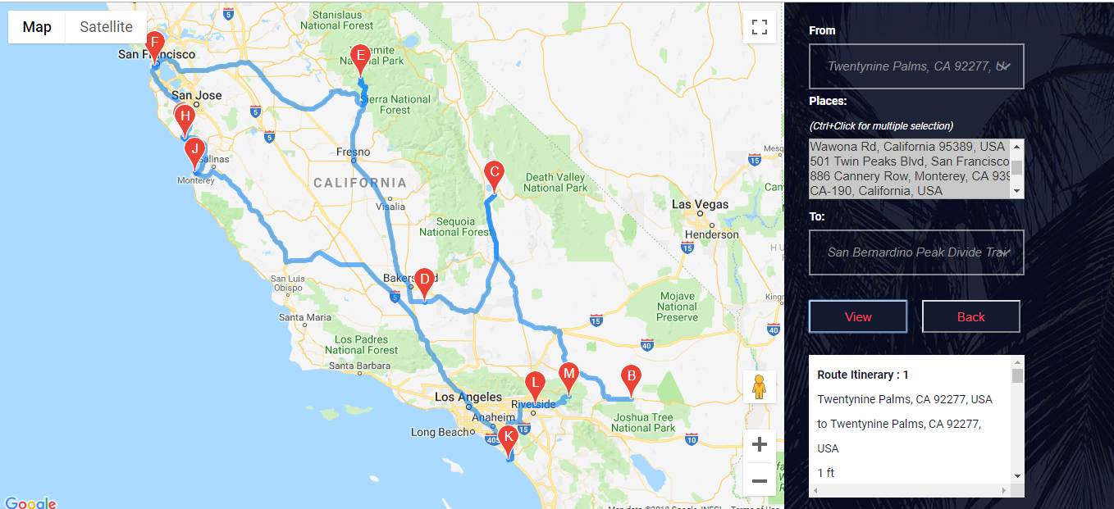

When we click on view places on Homepage ,it redirectes to directions page.In the directions page according to selection of the places it will show you the route map how the user can travel.

**About Us**

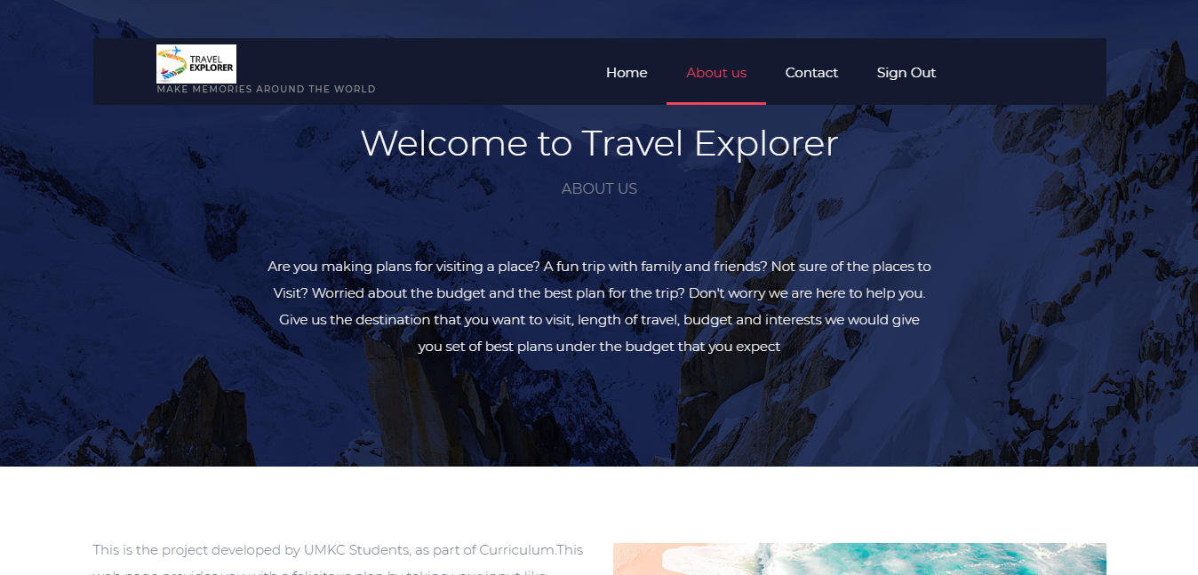

This page tells about why a user should be using our website.

**Contact Page**

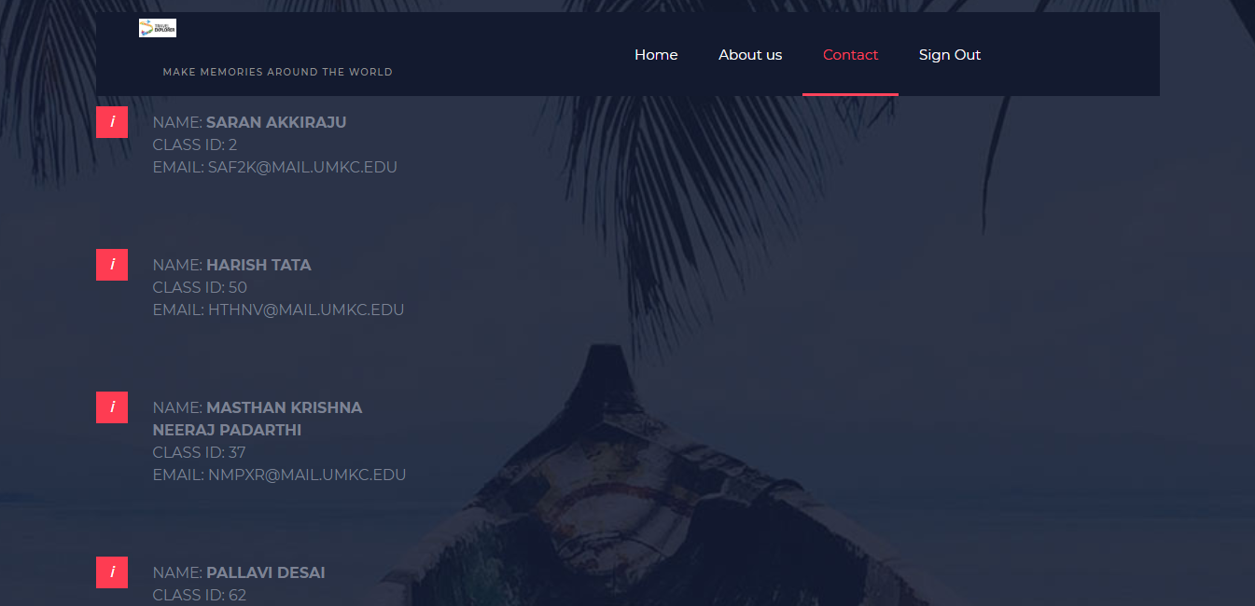

**Please find Github Wiki below:**

https://github.com/shannu1221/CS5551_Team8_Project/wiki/Project-Increment-2

**Project Management**

**Board Issues:**

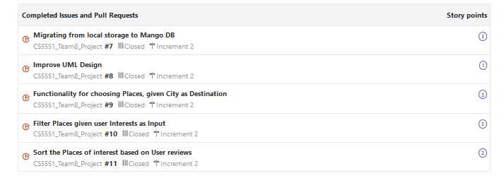

**ZenHub report:**

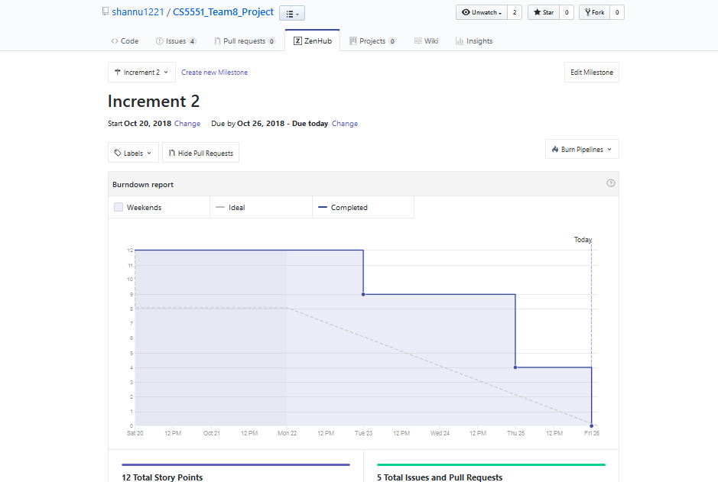

**Contribution chart:**

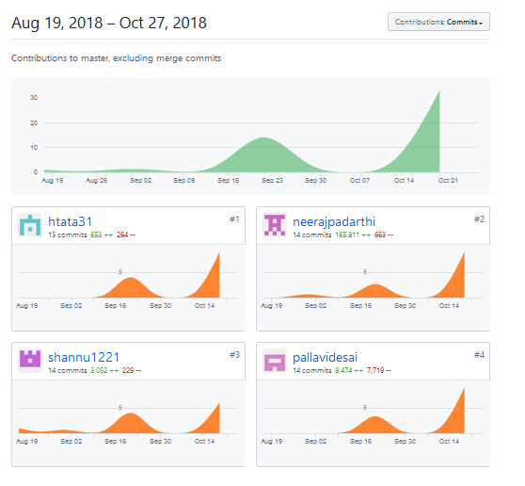

**Project Third Increment Report**

**Features developed for Increment3:**

1. Profile Page
2. History Page
3. Node modules for Forgot password, Successful Registration and Sending a mail to admin
4. Filtering Places based on user budget
5. Finding the shortest path of the places filtered on budget
6. Creation of Day to Day Plan

**Existing Services/REST API:**

<https://console.developers.google.com/google/maps-apis/>

**Detail Design of Features:**

1. **Wireframes& mockup:**

**HomePage**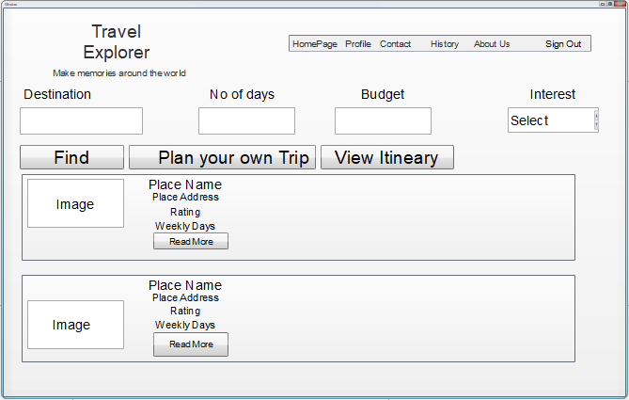

**Contact Page**

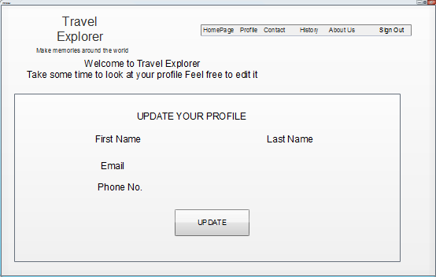

**Direction Page**

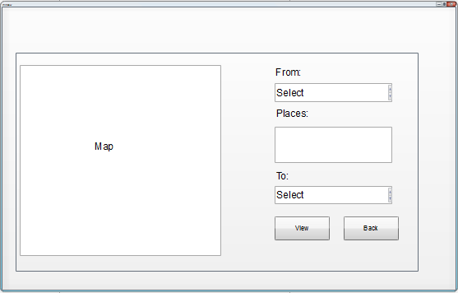

**History Page**

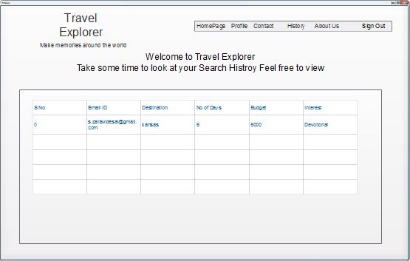

**Itineary Page**

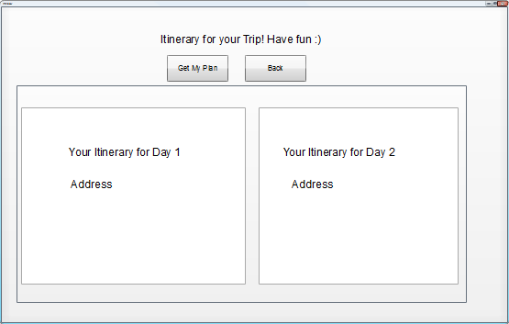

**About Us Page**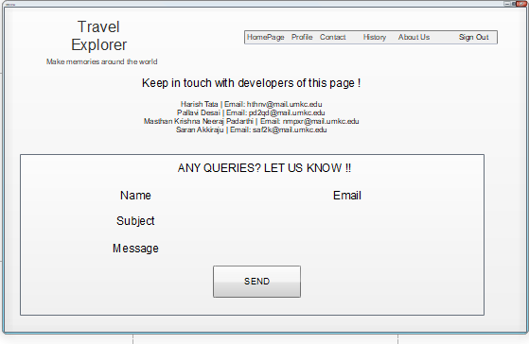

**Basic Functionality:**

Users will be able to see their profile details and also able to update their profile. Users will be able to see the history of searches by them.

Users will be able to receive email upon Successful Registration, on clicking forgot password link and also send email to admin of the application in case of any queries.

Filtering of the places can be done based on the budget given by the user. Application will fetch the details of the places which are rated high by the users in Google reviews and if they fall into the budget constraint given by the user.

There is an option for a user to create a custom plan, where user can select any place as source and destination, can look for a route in the maps and can also select multiple places and create their own.

Application creates a day to day plan considering the user budget, interest, number of days he/she planned to take the trip and also the places that are near to each other.

**2. 1 Architecture diagram:**



**2.2 Sequence Diagram:**

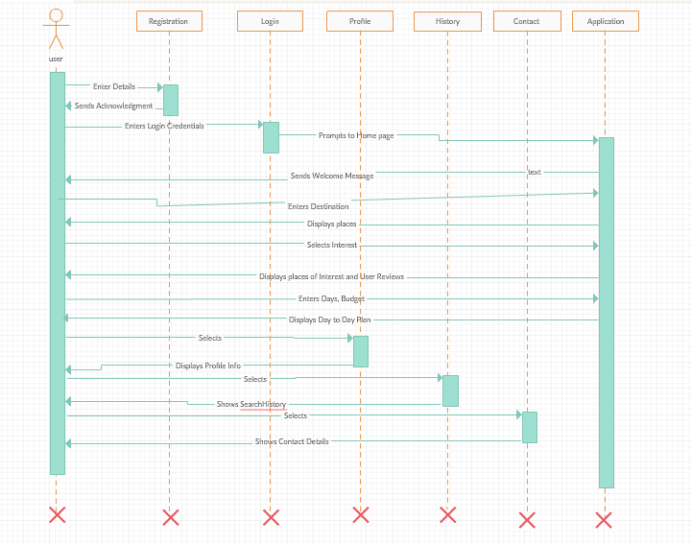

**2.3 Class Diagram:**

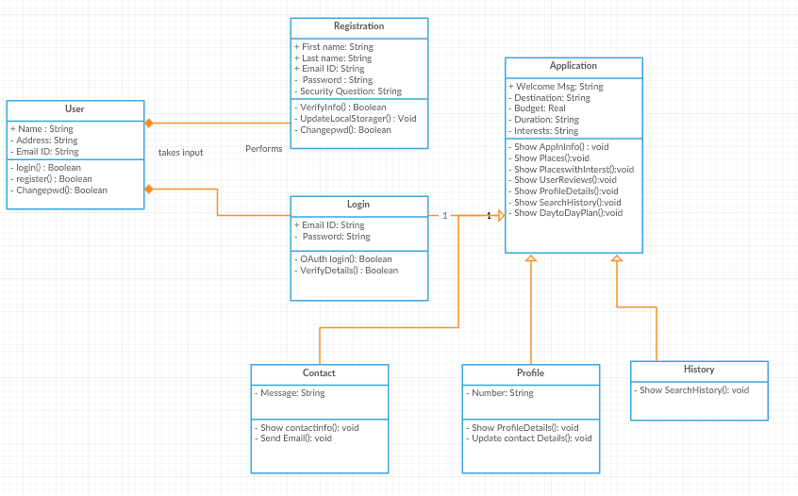

**3. User Stories**

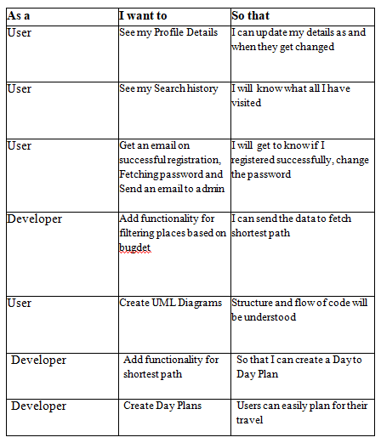

## 4. Testing

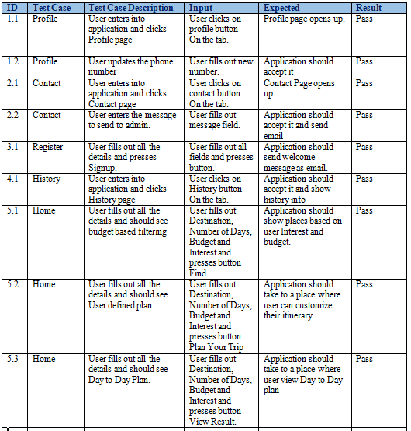

**Travel Explorer – Web Application:**

**Profile Page**

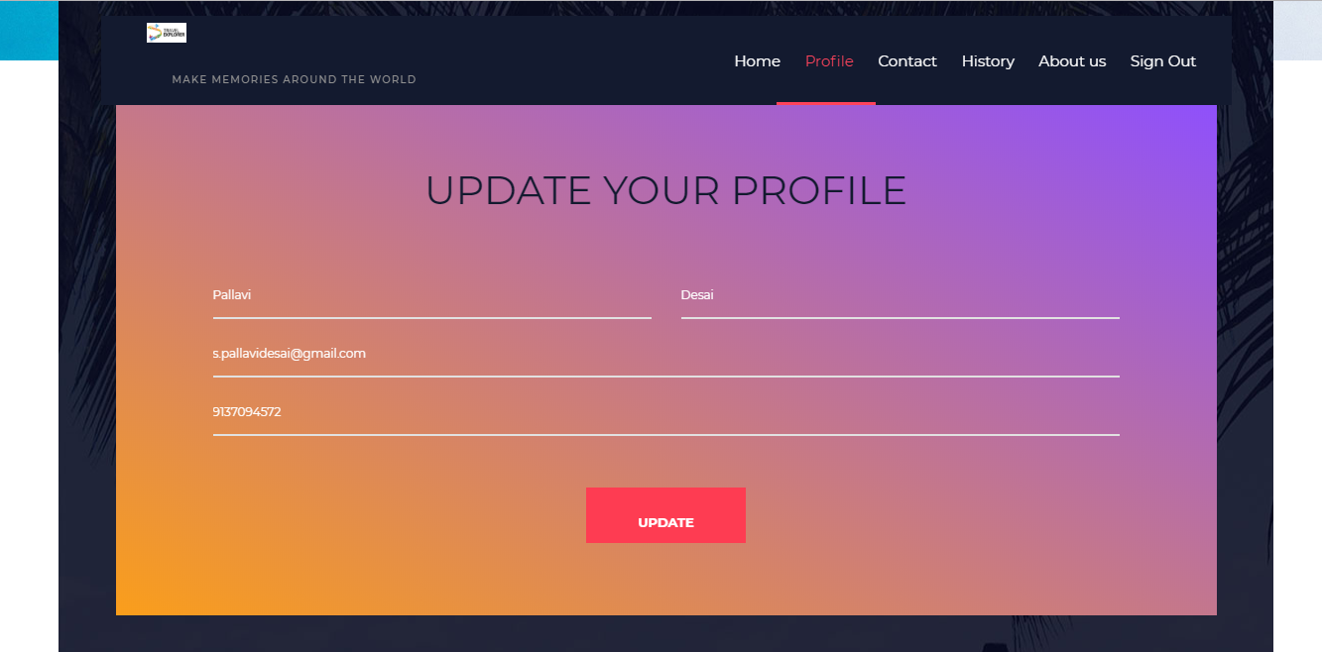

You can update the information like phone number last name etc.

**History Page **

This page shows all the history which is searched by the user before when he /she logged into the the account.

**Home Page**







You can see the searched places with the given interest and place with the given budget by the user.

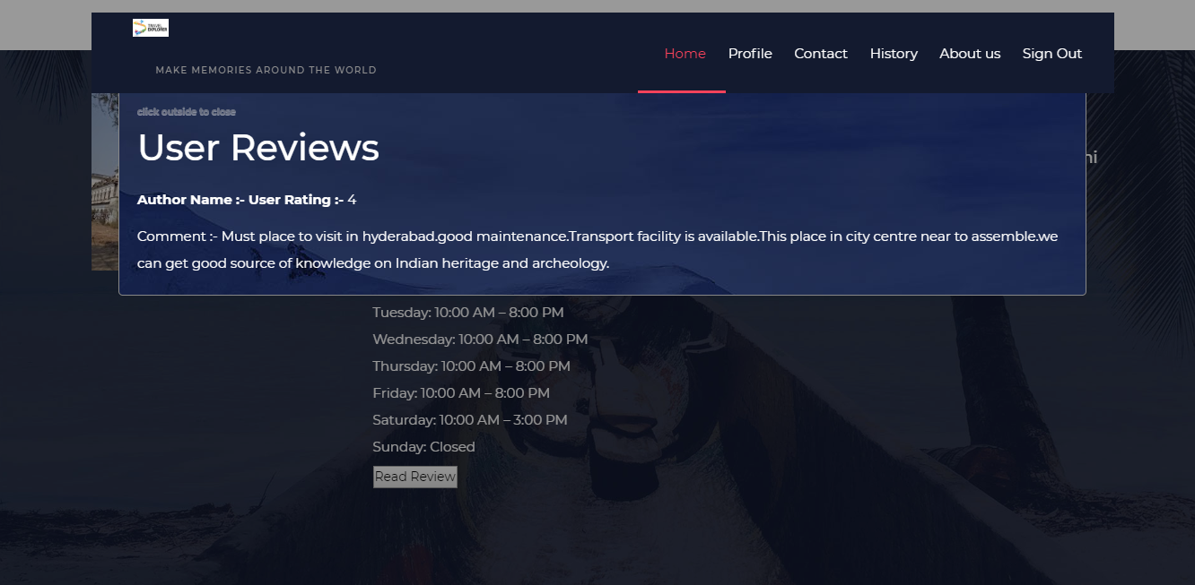

The user rating you can see in a popup ,So as to see that you can click on read more which displays the user rating and review of that particular place.

**User Customized Plan Page**



In this page the user can make his own plan with the help of place address present in the box .The user has to select from ,to and the waypoints (waypoints is optional) and make his own day or full trip plan

**Day to Day Plan Page**



Here is the itinerary given to user according to the budget constraint and the shortest path taken into the consideration

**Please find Github Wiki below:**

https://github.com/shannu1221/CS5551_Team8_Project/wiki/Project-Increment-3

**Project Management**

**Board Issues:**

**ZenHub report:**



**Contribution chart:**

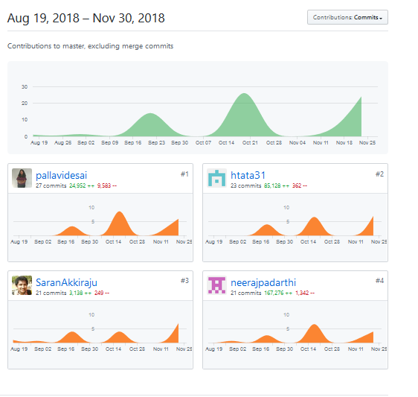

## Bibliography

## <https://developers.google.com/places/web-service/search>

## <https://developers.google.com/places/web-service/place-id>

## <https://developers.google.com/places/web-service/photos>

## <https://developers.google.com/maps/documentation/javascript/tutorial>

## <https://developer-tripadvisor.com/content-api/>

## <http://www.budgetyourtrip.com/api/>

## <https://get.google.com/trips/>

## <https://developers.google.com/knowledge-graph/>

## <https://colorlib.com/wp/free-travel-website-templates/>